Cardwell’s Revised
5th Grade Student Schedule
Instructional Delivery Model | Time | Activity
(LIVE) | SEL (Check-In)  7:45 - 8:00 | SEL (Check-In)  (15 min,/Synchronous)
(LIVE | Exploratory Classes  8:00 - 8:40 | Exploratory  40 min.
Break
8:40-8:50
(LIVE) | Mathematics  8:50 - 9:20 | Math (30 min./Synchronous-LIVE)
 | Mathematics  9:20- 9:40 | Math (20 min./Asynchronous-LIVE)
(LIVE) | Math Small Groups  9:40-10:10 | Math Small Groups  30 min.
Break
10:10-10:20
(LIVE) | Science  10:20- 10:50 | Science (30 min/Synchronous-LIVE)
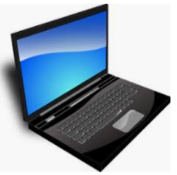 | Science  10:50- 11:00 | (10 min/Asynchronous-Independent Work)
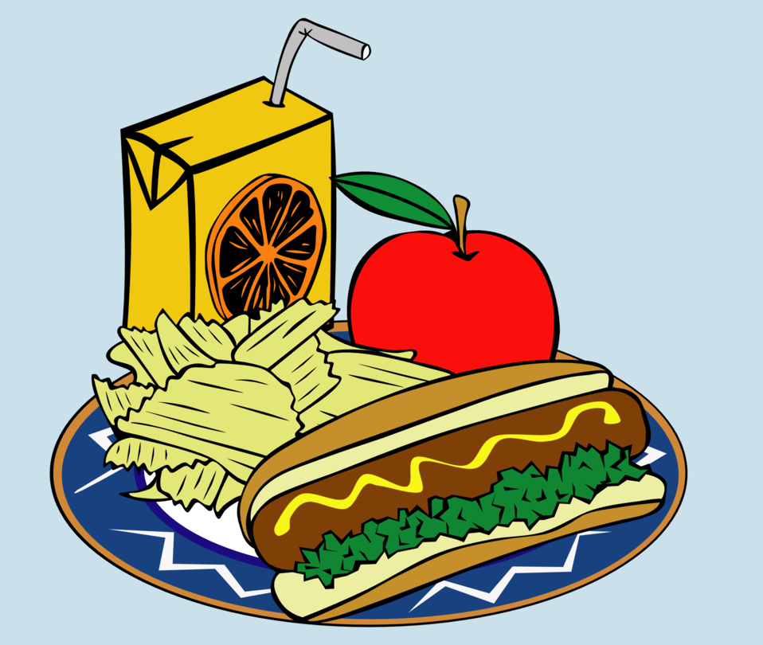 | Lunch 11:00 - 11:45 | LUNCH -45 min.

(LIVE) | Language Arts/Writing  11:45 – 12:20 | Language Arts (20 min./Synchronous- Live)  (15 min. Asynchronous- Independent Work)
(LIVE) | Reading  12:20 -12:50 | Reading (30 min./Synchronous-Live)
BREAK
12:50 – 1:00
 | Reading  1:00-1:15 | Reading (15 min./Asynchronous-Independent Work)
(LIVE) | Social Studies  1:15 – 2:00 | Social Studies (20 min./Synchronous-Live)  (15 min. Asynchronous-Independent Work)

